CSC · CMMI ML 5.0 (DEVELOPMENT) AND ML 3.0 (SERVICES)
Entity Relationship Diagram
The eleven tables behind the CMMI data collection repository: what each one holds, every foreign key, and the column catalogue the sheets are mapped onto.
Read from the live MySQL schema. Row counts as at 9 October 2026.

1. The schema at a glance
Three reference tables are seeded once by scripts/init_db.py and change rarely. Everything to the right of them is written by an upload. The two record tables are separate because a Development row and a Services row describe different things — forcing them into one table would mean a column that is null for half the data.
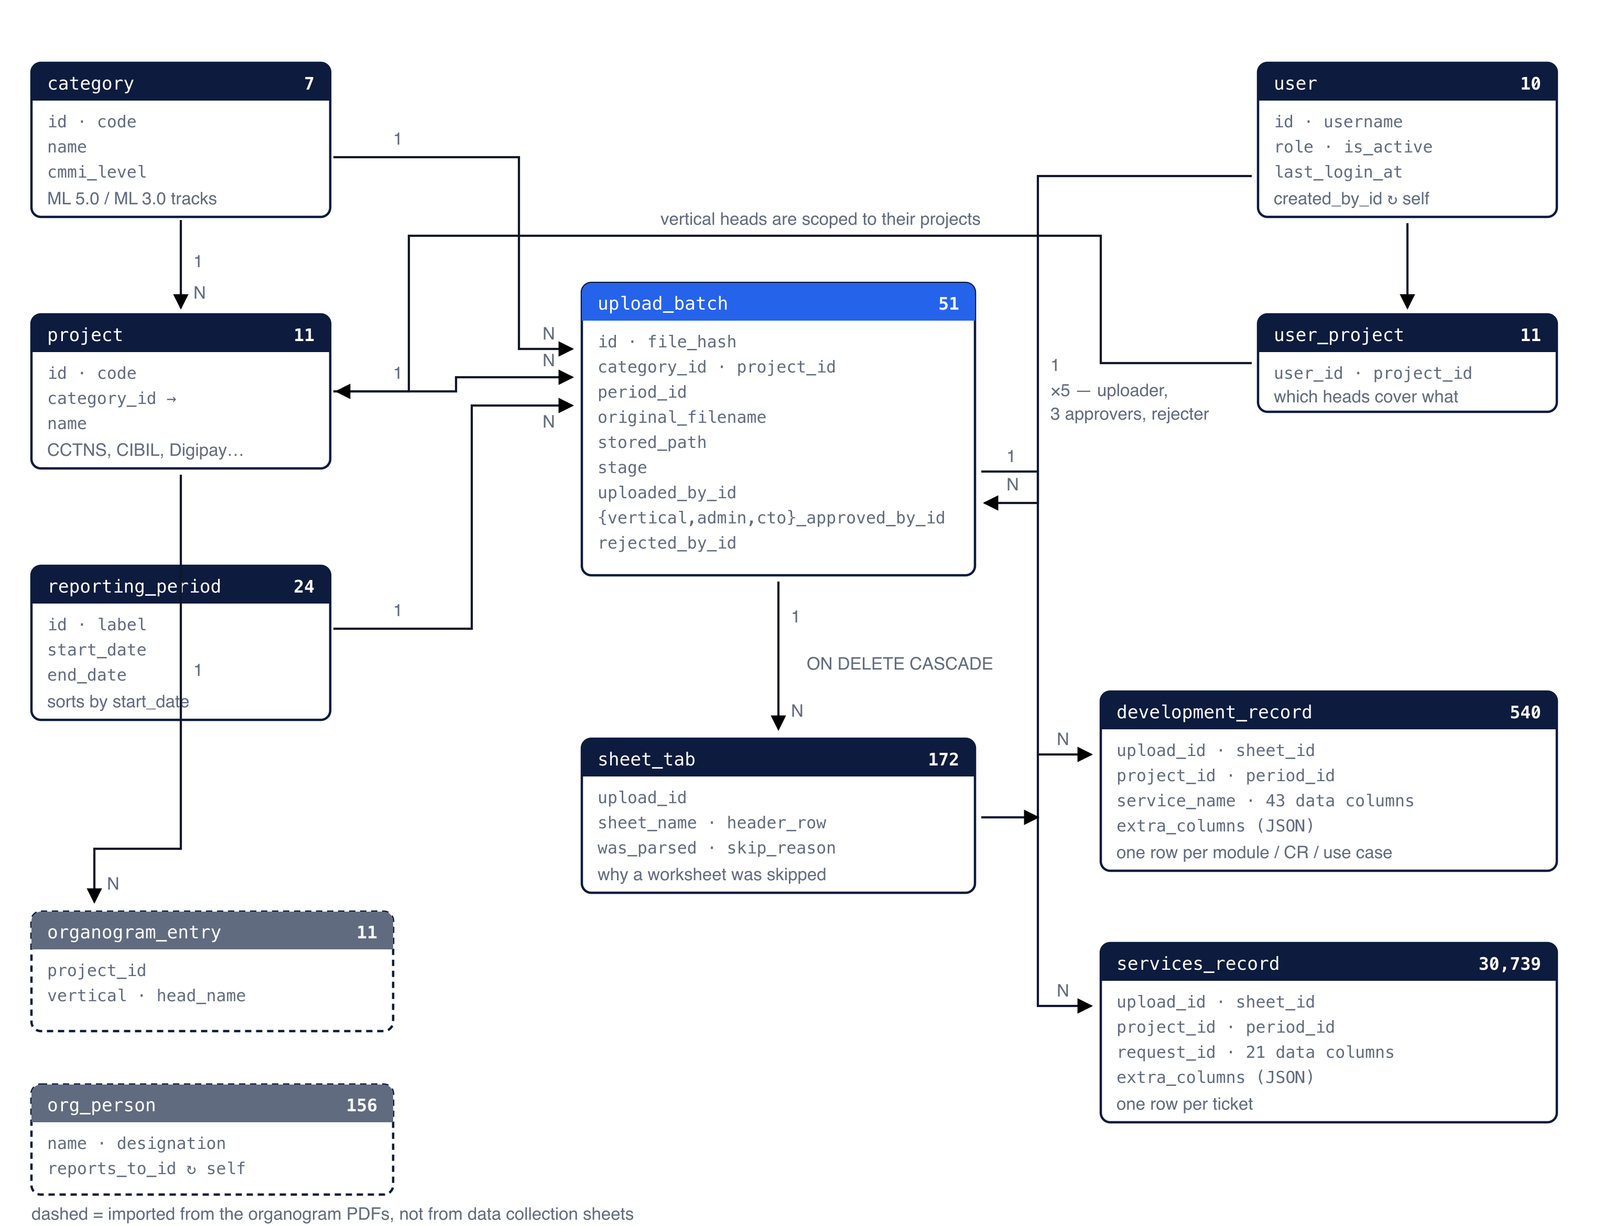
Figure 1. Both record tables carry project_id and period_id even though upload_batch already has them. That is deliberate denormalisation — it lets a modelling query group 30,739 service rows by period without a join.

2. Tables
Row counts taken from the running database. 'Written by' says what causes rows to appear.
TABLE | ROWS | HOLDS | WRITTEN BY
category | 7 | The two active tracks plus five further ML 3.0 views of the model | Seeded
project | 11 | Six Development projects, five Services projects | Seeded
reporting_period | 24 | Cycles and months, with real start and end dates | Seeded / grown
user | 10 | Sign-ins: one admin, one CTO, seven vertical heads, one shared uploader | Managed
user_project | 11 | Which projects each vertical head covers | Managed
upload_batch | 51 | One uploaded workbook: who, when, hash, stage, every sign-off | Per upload
sheet_tab | 172 | Each worksheet, its header row, or why it was skipped | Per upload
development_record | 467 | One row per module / CR / use case — 43 data columns | Per upload
services_record | 30,739 | One row per ticket — 21 data columns | Per upload
organogram_entry | 11 | Vertical and head per project, behind every approval queue | Seeded once
org_person | 156 | The reporting tree, self-referencing through reports_to_id | Seeded once

3. Every foreign key
Twenty-five in all. CASCADE marks the ones that delete with their parent; the rest restrict.
TABLE | COLUMN | REFERENCES
project | category_id | category.id
upload_batch | category_id | category.id
upload_batch | project_id | project.id
upload_batch | period_id | reporting_period.id
upload_batch | uploaded_by_id | user.id
upload_batch | vertical_approved_by_id | user.id
upload_batch | admin_approved_by_id | user.id
upload_batch | cto_approved_by_id | user.id
upload_batch | rejected_by_id | user.id
sheet_tab | upload_id | upload_batch.id (CASCADE)
development_record | upload_id | upload_batch.id (CASCADE)
development_record | sheet_id | sheet_tab.id (CASCADE)
development_record | category_id | category.id
development_record | project_id | project.id
development_record | period_id | reporting_period.id
services_record | upload_id | upload_batch.id (CASCADE)
services_record | sheet_id | sheet_tab.id (CASCADE)
services_record | category_id | category.id
services_record | project_id | project.id
services_record | period_id | reporting_period.id
user | created_by_id | user.id (self)
user_project | user_id | user.id
user_project | project_id | project.id
organogram_entry | project_id | project.id
org_person | reports_to_id | org_person.id (self)

4. Provenance on every data row
Both record tables carry the same five provenance columns in addition to their data columns, so a single table answers most questions without a join.
COLUMN | MEANING
upload_name | The file it was uploaded as. Half of the row's identity.
period_label | Denormalised from reporting_period for easy querying.
sheet_name | The worksheet it came from.
row_index | 1-based row number in that worksheet, so a value can be traced to a cell.
extra_columns | JSON. Any heading the catalogue did not recognise, kept rather than dropped.

5. The column catalogue
Each heading a team wrote is matched to one fixed column. The sheets do not agree with each other — column counts range from 19 to 76 and the same measure is written several ways — so the catalogue is what keeps the table a stable shape.

development_record — 43 data columns
• Identity department, project_name, service_name
• Size size, size_old, size_new
• Effort planned_effort, actual_effort, ra_actual_effort, design_actual_effort, coding_actual_effort, crut_effort, testing_actual_effort
• Dates planned_start, planned_end, actual_start, actual_end, ra_start, ra_end, design_start, design_end, cut_start, cut_end, crut_start, crut_end, testing_start, testing_end, uat_start, uat_end, golive_date
• Duration ra_duration, design_duration, cut_duration, testing_duration
• Rates coding_rate, crut_rate, testing_rate
• Quality test_cases, req_review_defects, design_review_defects, code_review_defects, internal_testing_defects, external_defects

services_record — 21 data columns
• Identity request_id, client, description
• Classification ticket_category, priority, kedb, assigned_to, status
• Outcome reopen, rejections_complaints, remarks
• Response logging_datetime, response_datetime, response_time, response_defined_sla, response_sla_compliance
• Resolution resolution_datetime, resolution_time, resolution_defined_sla, resolution_sla_compliance, closure_date
The Services logs repeat 'Defined SLA' and 'SLA Compliance' twice — once after the response columns, once after the resolution columns. They are told apart by position and stored separately, which is why there are two of each above.

Headings deliberately not stored
These are recognised and skipped, so they are not treated as unknown columns:
• S.No. and its variants — sno, sr no, serial no. A row counter carries no information.
• The FOR MQAS USE block — cycle time, effort variance, productivity, defect removal effectiveness. MQAS fills these in, not the project teams, and all four are derivable from the stored columns.

6. Design decisions

Row identity is the file plus the row's own name
service_name for Development, request_id for Services. Both pairs are indexed but neither is unique: Request IDs genuinely repeat in the Services logs — five do in the DSP e-district June 2026 sheet alone — so a unique key would reject real rows.

Deletion cascades
sheet_tab and both record tables cascade from upload_batch, and the batch row carries the approvals, so a DELETE removes the upload, its rows and its sign-offs together. Only an administrator can delete. This is the one gap in the audit trail, and closing it would need a separate append-only log table.

There is no audit table
The activity trail is derived at request time from the timestamp columns on upload_batch and user — one batch row produces up to five dated events: the upload, three approvals and a rejection. Those columns are the record of truth, so a trail read from them cannot drift from what it describes. A separate log would be a second copy of the same facts and could.

Nothing derivable is stored
No sort_order on categories — they come back in the order seed.py lists them. No year or quarter on a period — YEAR(start_date) and QUARTER(start_date) give the same answer and cannot drift out of step. No sort_key — ORDER BY start_date replaces it, and periods without dates sort last.

Unrecognized headings are kept
A heading the catalogue does not know goes into the row's extra_columns JSON field and is flagged on the upload page, so nothing is lost and the table stays the same shape. A worksheet that is not a data collection sheet still gets a sheet_tab row recording why it was skipped.

7. Querying it
The shape is deliberately plain: one row per spreadsheet row, the sheet's columns as real columns, so ordinary SQL works with no reshaping.
-- productivity and effort variance by period
SELECT period_label,
COUNT(*) AS rows_n,
ROUND(AVG(size_new / actual_effort), 4) AS productivity,
ROUND(AVG((actual_effort - planned_effort)
/ planned_effort * 100), 1) AS effort_variance_pct
FROM development_record
WHERE actual_effort > 0
GROUP BY period_label;
Sheets vary in which size column they use, so for modelling take the first one present:
SELECT service_name, COALESCE(size, size_new, size_old) AS size_pts
FROM development_record;
To restrict to approved data, join upload_batch and filter on the stage — that is what the web pages do by default:
SELECT r.*
FROM services_record r
JOIN upload_batch b ON b.id = r.upload_id
WHERE b.stage = 'approved';
Drawn from app/models.py, app/ingest.py, app/metrics_catalog.py and app/main.py, with row counts and foreign keys read from the live MySQL schema on 9 October 2026. Source diagrams: docs/*.svg.

